# ELEC-240 Lab4

# Interfacing External Hardware to the STM32F429 Nucleo-144 Development Board

## 1 Introduction

This lab task covers interfacing external hardware to the GPIO pins of the STM32F429

Nucleo-144 development board. Specifically, this lab exercise focusses on driving externally

connected LEDs using the GPIO pins configured as outputs.

When configured as an output the GPIO pin uses two transistors which are alternately

switched to pull the output either up to VDD (3.3V) or down to GND (0V), see Figure 1.

This is called Push-Pull (Figure 1a) and is the default operation mode.

Alternatively, the pin can be configured in software using the OTYPER register to operate

in `Open-Drain' mode (Figure 1b). In Open-Drain mode the upper transistor is disconnected

leaving only the lower (GND connecting) transistor operating.

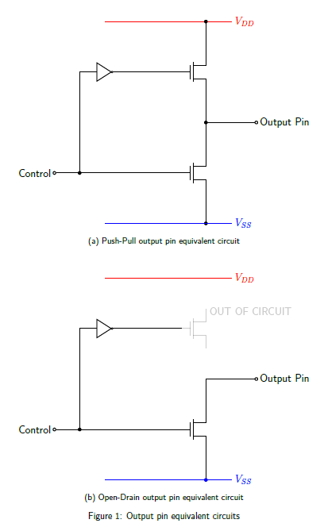

### 1.1 Learning Outcomes

* By the end of this lab exercise you should be able to:

1. Demonstrate an understanding of
   1. GPIO architecture
   2. GPIO output modes and their uses
   3. Current sourcing and sinking
   4. Current limiting resistor function and how to calculate the required value
2. Produce code to configure a GPIO pin as a digital output in either mode
3. Connect an external LED to a GPIO pin in a current-source and current-sink arrangement

### Task 1

From Table 2 refer to the STM32F427/429 family datasheet pin assignments section to

identify GPIO pins that are not being used by other peripherals on GPIOD.

* From the Electrical characteristics section identify:

1. The maximum output current each I/O pin can sink?
2. The maximum output current each I/O pin can source?
3. The maximum total current into the VDD (3.3V power) pin?
4. The maximum total current out of the VSS (ground) pin?

### Task 2

1. How much current is required to illuminate the LEDs according to their respective datasheets? (Table 2)
2. What is the maximum number of LEDs the Nucleo-144 board can drive directly from a single I/O pin using this current?
3. Is it possible to illuminate three LEDs from a single GPIO pin?
4. Is it possible to illuminate two LEDs from a single GPIO pin?

### Task 3

Calculate the resistor values required to provide each LED with the current and voltage

specified in the datasheet when supplied from a GPIO pin and select the Nearest Preferred

Value (NPV) resistor from the `E24' range available in the lab ([Chart Here](http://www.ohmslawcalculator.com/e24-resistor-sizes)).

### Task 4

The Module Support Board (see Fig2 and [datasheet](https://dle.plymouth.ac.uk/mod/resource/view.php?id=970667)) has three LEDs (TRAF_RED1, TRAF_YEL1, TRAF_GRN1) connected to Port C pins (PC2, PC3, PC6) respectively. The circuit requires the port pin to **source current** to drive the base of an NPN transistor to turn it on and thereby illuminate the corresponding LED.

1. Configure the required pins to be **OUTPUTS** in **PUSH-PULL** mode
2. Write some code to flash each LED at a different frequency.
3. Change the mode of the pins to be OPEN DRAIN and note what happens.

* Make sure all code generated for the LEDs is in a file called ***LED.c*** and all functions are declared in ***LED.h*** and have “good” **comments.**

### Task 5

The Module Support Board has another three LEDs (TRAF_RED2, TRAF_YEL2, TRAF_GRN2) connected to Port C pins (PC7, PC8, PC9) respectively.

The circuit that drives these LEDs use a PNP transistors that require the base to **sink current** to turn them on**.**

1. **Copy** the code generated for TASK 4 and **Modify** to flash these LEDs in both

**PUSH-PULL** and **OPEN DRAIN** modes and note how the LEDs behave in each case.

1. Explain how the circuit that drives these LEDs functions.
2. What are the benefits of using open-drain pins?

### Task 6

1. Write a program to control both banks of Red, Yellow, & Green LEDs to mimic traffic lights at a junction (i.e When one traffic light is red the other traffic lights should go to green and vice versa following the sequence (RED, RED+YEL, GRN, YEL, RED)

NOTE: Make sure both lights are set to RED for SAFETY before one or other goes to green!

1. Extend the above program to incorporate the Blue User push-button to emulate a pedestrian crossing, where TRAF_WHITE LED is provided to emulate the GREEN MAN that is illuminated when both sets of traffic lights are RED to allow pedestrians to cross.

NOTE: Refer to the UM1974 User manual to identify which pin the User Button is connected and Module Support Datasheet which pin TRAF_WHITE is connected

1. Make the GREEN MAN illuminate for 10s THEN **flash** for 10s before it goes out to inform pedestrians that the lights are about to change.

* Make sure ALL registers relating to the function of each port pin used are set in the initialisation code. **Do not assume the default condition is zero.**

|  |  |
| --- | --- |
| **Register Name** | **Reference Manual Section** |
| Hardware Clock Enable Register (AHB1ENR) | 6.3.10 |
| GPIO port mode register (MODER) | 8.4.1 |
| GPIO port output type register (OTYPER) | 8.4.2 |
| GPIO port output speed register (OSPEEDR) | 8.4.3 |
| GPIO port pull-up/pull-down register (PUPDR) | 8.4.4 |
| GPIO port input data register (IDR) | 8.4.5 |
| GPIO port output data register (ODR) | 8.4.6 |
| GPIO port bit set/reset register (BSRR) | 8.4.7 |

**Table 1:** Table of relevant control registers for configuring and controlling GPIOs

## 2.Support Documentation

|  |  |
| --- | --- |
| Document Name | Contained Information |
| [UM1974 User manual](https://www.st.com/content/ccc/resource/technical/document/user_manual/group0/26/49/90/2e/33/0d/4a/da/DM00244518/files/DM00244518.pdf/jcr:content/translations/en.DM00244518.pdf) | * Pin identification and the supported special functions * Circuit schematics * Jumper and component identification * Header pinouts |
| [RM0090 Reference manual](https://www.st.com/content/ccc/resource/technical/document/reference_manual/3d/6d/5a/66/b4/99/40/d4/DM00031020.pdf/files/DM00031020.pdf/jcr:content/translations/en.DM00031020.pdf) | * MCU memory and peripherals architecture * Peripheral control registers, addresses and bit-fields |
| [Green LED Datasheet](https://static.rapidonline.com/pdf/55-1792.pdf)  [Red LED Datasheet](https://static.rapidonline.com/pdf/55-1796.pdf)  [Yellow LED Datasheet](https://static.rapidonline.com/pdf/55-1794.pdf)  [White LED Datasheet](https://static.rapidonline.com/pdf/55-1758.pdf) | * Features * Applications * Absolute maximum rating * Electrical – Optical characteristics |
| [E24 Resistor Chart](http://www.ohmslawcalculator.com/e24-resistor-sizes) | * Table of Standard Resistor Values |
| [STM32F427/429 family datasheet](https://www.st.com/content/ccc/resource/technical/document/datasheet/03/b4/b2/36/4c/72/49/29/DM00071990.pdf/files/DM00071990.pdf/jcr:content/translations/en.DM00071990.pdf) | * Functional overview * Pinouts and pin description * Memory mapping * Electrical characteristics * Package information |
| [Nucleo F429ZI Module Support Board](https://dle.plymouth.ac.uk/mod/resource/view.php?id=970667) | * Circuit Diagram * Pinout and Port Usage |

**Table 2:** Table of relevant support documentation

(The document names are hyperlinks, please click on them to access the documents)

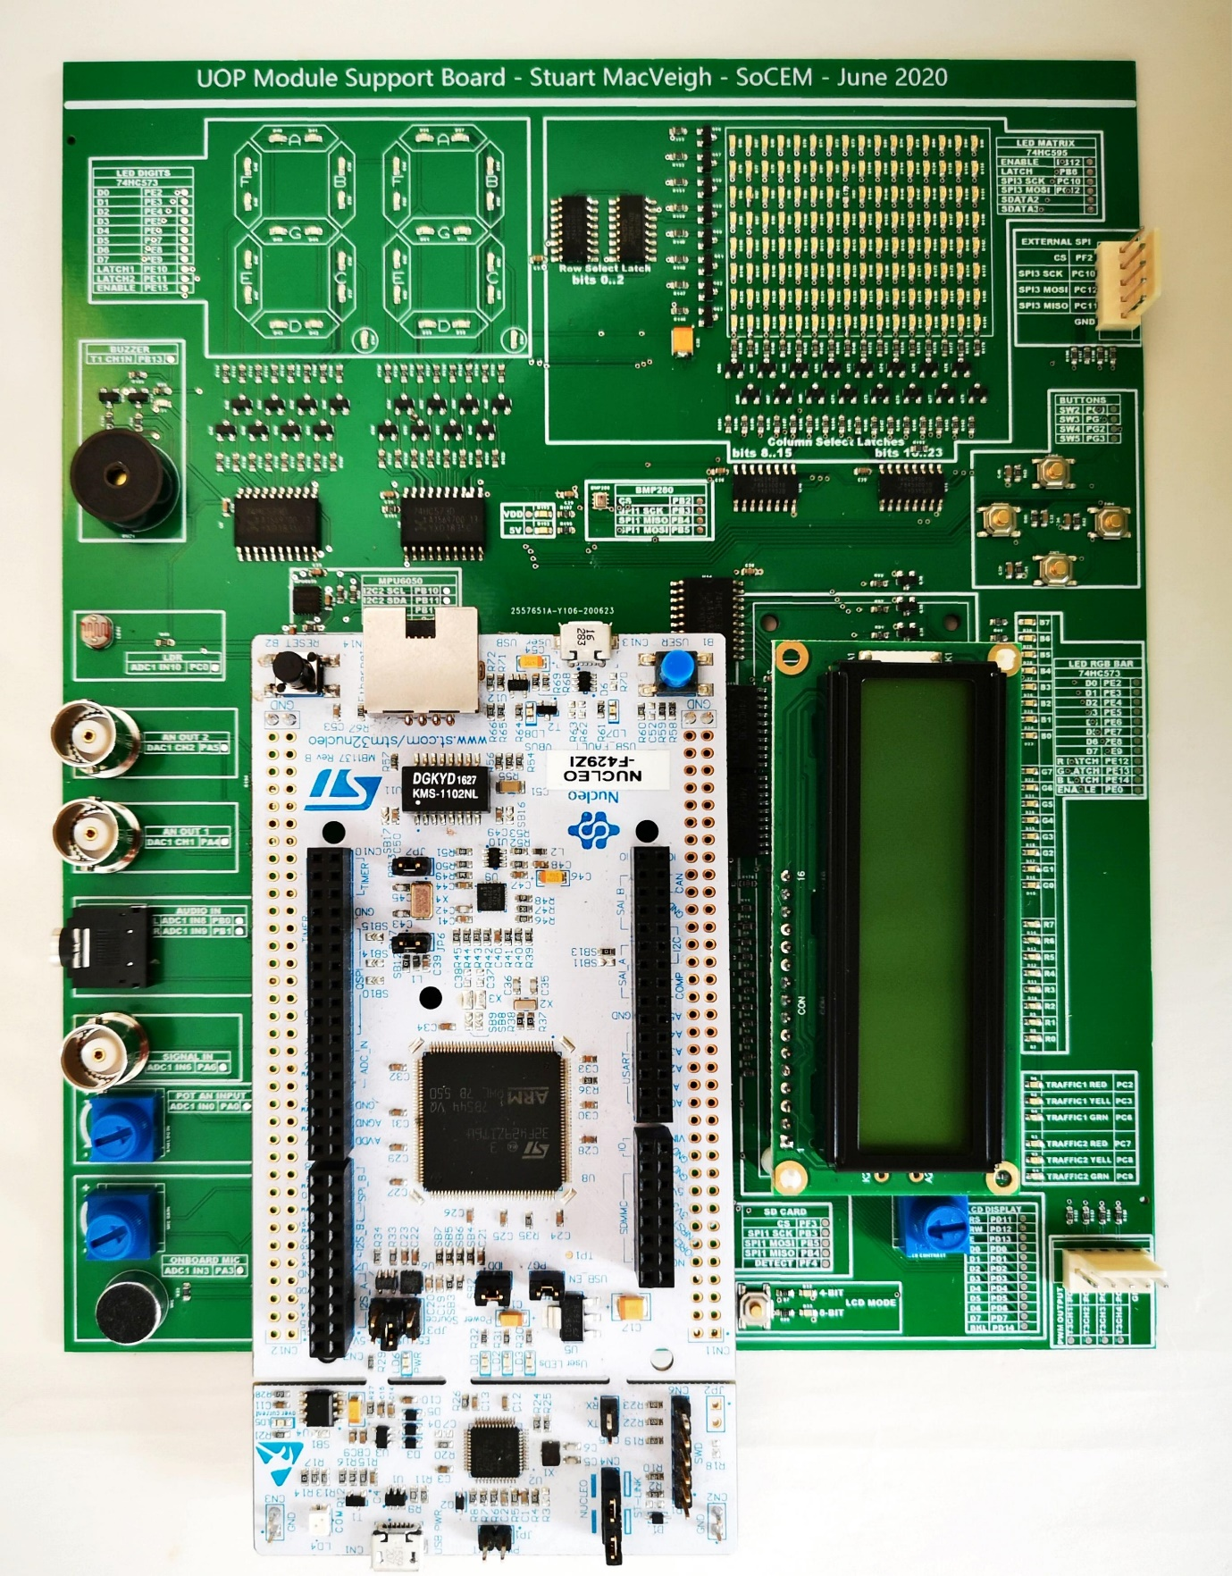

TRAFFIC LIGHT LEDs

Fig, 2 Module Support Board